**SDoC Identification Number1:**

006-SDoC-WK

**Issuer details**

Name2 (of New Zealand manufacturer or importer)**:** Contact Address:

Telephone:

New Zealand Company No. (if applicable):

Email Address:

info@heirloom.co.nz

Heirloom International Limited

3-5 Analie Place,

East Tamaki

Auckland,

New Zealand

+64 9 274 4443

398705

**Medium Risk Article – Details3 (Product name, type, rating, brand, model, batch numbers, and serial numbers, as applicable):**

WK510, WK510E, WK825, WK825S, WK1025, WK1220S

WKE510, WKE510E, WKE825, WKE825S, WKE1025

**The Medium Risk Article listed above, fully complies:**

**With cited standard(s), as listed**4**:**

Standard number and issue year: Standard number and issue year:

Edition / Amendment status: Edition / Amendment status:

Standard title: Standard title:

AS/NZS ZZ modified Yes No N/A AS/NZS ZZ modified Yes No N/A

**OR Complies with the Conformity Cooperation Agreement**5 Yes No

AS/NZ S60335.1 :2011

AS/NZS60335.2.43:2005

+A1 - A2

+A1

Household and similar electrical appliances

Household and similar electrical appliances

✓   ✓

**Names and addresses of any testing organisation or body**

Name(s): Address(es):

Name(s): Address(es):

21 Tarndale Grove,

Albany,

Auckland, New Zealand

UL International NZ Ltd

**Reference to relevant test reports/certification and the issue date that show how compliance is achieved**

Standard(s) or document(s) used, to show how compliance Report Certification or Document Issue dates(s):

with cited standard is achieved: reference N°(s):

Reference to any management quality system involved:

Reference to any management quality system involved:

Additional information6:

17-9-2010

17-12-2013

13-8-2014

20-9-2019

14-12-2023

10CA15417-SA00

13CA47719-SA00

4786410425-SC001

12996005:SA00

15027794-SC00

AS/NZS 60335.1 : 2011 + A1

AS/NZS 60335-2.43 : 2005 + A1-A2

IP56 Test

AS/NZS30335.2 2020+A1 ; AS/NZS60335.2.43 2018

**Declaration** **(signed for and on behalf of) Heirloom International Limited**

**Name and position as authorized by the issuer7: Signature:**

**Issuer Identification (as affixed to the article):**

**Date:**

Barney Sullivan, Product Development Manager

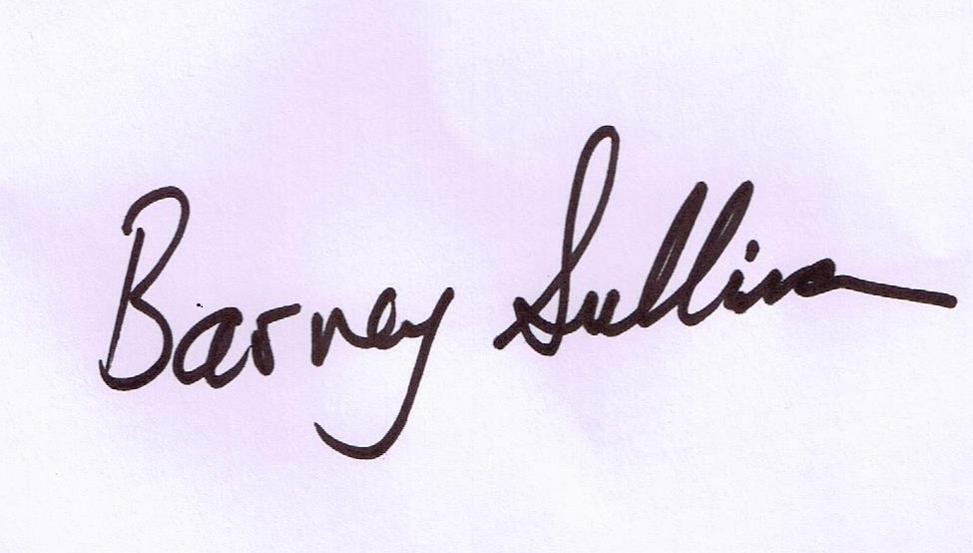

15 December 2023

2014

