**SDoC Identification Number1:**

021-SDoC-WG

**Issuer details**

Name2 (of New Zealand manufacturer or importer)**:** Contact Address:

Telephone:

New Zealand Company No. (if applicable):

Email Address:

info@heirloom.co.nz

Heirloom International Limited

3-5 Analie Place,

East Tamaki

Auckland,

New Zealand

+64 9 274 4443

398705

**Medium Risk Article – Details3 (Product name, type, rating, brand, model, batch numbers, and serial numbers, as applicable):**

Heirloom Genesis range of towel warmers: NOTE: xx refers to colour

WG1220xx, WG1220Sxx, WG1220T, WG1025E, WG1025xx, WG825xx, WG825Sxx, WG510Exx, WG510xx, WGE1220, WGE1025, WGE825, WGE825S, WGE510E, WGE510.WG510T, WG510S, Freestanding WGF920

**The Medium Risk Article listed above, fully complies:**

**With cited standard(s), as listed**4**:**

Standard number and issue year: Standard number and issue year:

Edition / Amendment status: Edition / Amendment status:

Standard title: Standard title:

AS/NZS ZZ modified Yes No N/A AS/NZS ZZ modified Yes No N/A

**OR Complies with the Conformity Cooperation Agreement**5 Yes No

AS/NZ S60335.1 :2011

AS/NZS60335.2.43:2005

+A1 - A2

+A1

Household and similar electrical appliances

Household and similar electrical appliances

✓   ✓

**Names and addresses of any testing organisation or body**

Name(s): Address(es):

Name(s): Address(es):

21 Tarndale Grove,

Albany,

Auckland, New Zealand

UL International NZ Ltd

**Reference to relevant test reports/certification and the issue date that show how compliance is achieved**

Standard(s) or document(s) used, to show how compliance Report Certification or Document Issue dates(s):

with cited standard is achieved: reference N°(s):

Reference to any management quality system involved:

Reference to any management quality system involved:

Additional information6:

AS/NZS60331.1:2011 +A1 AS/NSZ60335.2.43 +A1-A2

AS/NZS60335.1 2011 +A1-A4

AS/NZS60335.1:2020, AS/NZS60335.2.43:2018

12873703-SA00 [4]

12873703-SB00 [5]

13979791-SA00  
14427802-SA00  
14606505-SA00 [6]

15027794-SA00

10 July 2019

10 July 2019

20 December 2021

23 August 2022

22Dec 2022

14 Dec 2023

**Declaration** **(signed for and on behalf of) Heirloom International Limited**

**Name and position as authorized by the issuer7: Signature:**

**Issuer Identification (as affixed to the article):**

**Date:**

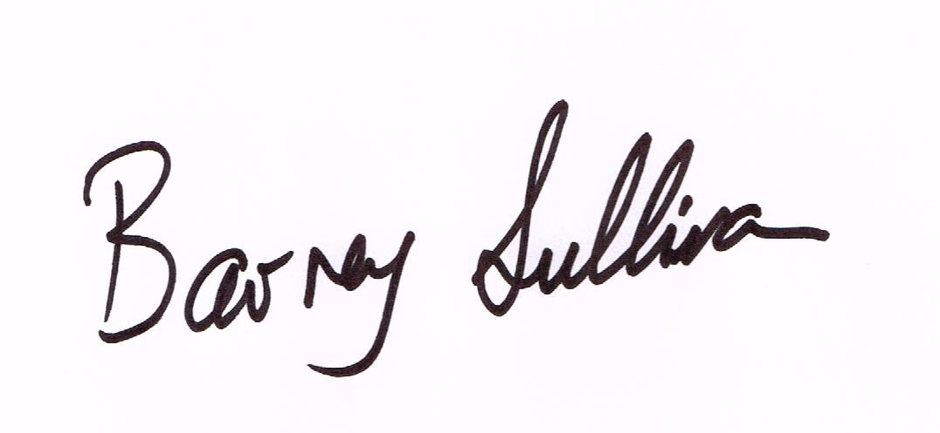

Barney Sullivan, Product Development Manager

15 December 2023

2014

