**SDoC Identification Number1:**

049SDoCPEP

**Issuer details**

Name2 (of New Zealand manufacturer or importer)**:** Contact Address:

Telephone:

New Zealand Company No. (if applicable):

Email Address:

info@heirloom.co.nz

Heirloom International Limited

3-5 Analie Place,

East Tamaki

Auckland,

New Zealand

+64 9 274 4443

398705

**Medium Risk Article – Details3 (Product name, type, rating, brand, model, batch numbers, and serial numbers, as applicable):**

Peppy Instant Boiling Tap 4IN1BAxx (CH chrome; MB black; BN Brushed Nickel; GMG Gunmetal; BBG Brushed Brass

Peppy Instant Chilled Tap 4IN1BCxx (CH chrome; MB black; BN Brushed Nickel; GMG Gunmetal; BBG Brushed Brass

**The Medium Risk Article listed above, fully complies:**

**With cited standard(s), as listed**4**:**

Standard number and issue year: Standard number and issue year:

Edition / Amendment status: Edition / Amendment status:

Standard title: Standard title:

AS/NZS ZZ modified Yes No N/A AS/NZS ZZ modified Yes No N/A

**OR Complies with the Conformity Cooperation Agreement**5 Yes No

AS/NZS60335.1 :2020

AS/NZS60335.2.15:2019

+A1

Household and similar electrical appliances

Household and similar electrical appliances

✓   ✓

**Names and addresses of any testing organisation or body**

Name(s): Address(es):

Name(s): Address(es):

695 The Horsley Drive, Smithfield,NSW, Australia

Conformity Certification Services

**Reference to relevant test reports/certification and the issue date that show how compliance is achieved**

Standard(s) or document(s) used, to show how compliance Report Certification or Document Issue dates(s):

with cited standard is achieved: reference N°(s):

Reference to any management quality system involved:

Additional information6:

EESS-220919

15 Nov 2022

AS/NZS60335.1 2020 +A1

AS/NZS60335.2.15 2019

**Declaration** **(signed for and on behalf of) Heirloom International Limited**

**Name and position as authorized by the issuer7: Signature:**

**Issuer Identification (as affixed to the article):**

**Date:**

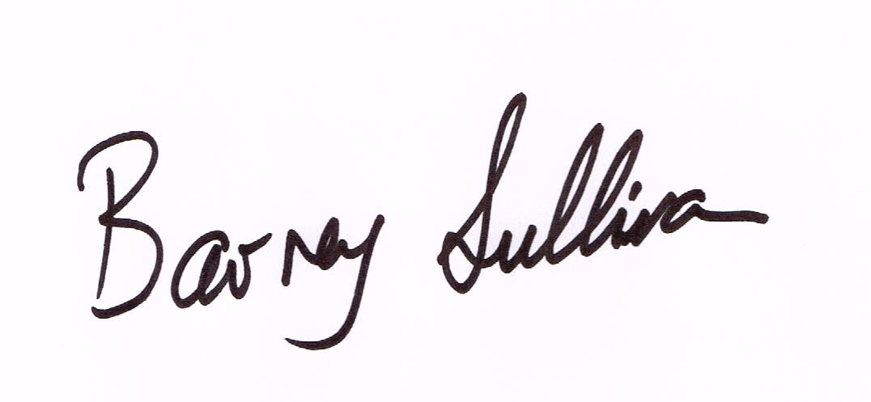

Barney Sullivan, Product Development Manager

17 August 2023

2014

