SDoC Identification Number¹:
036-SDoC-WSTR

Issuer details

Name² (of New Zealand manufacturer or importer): Contact Address:

Telephone:
New Zealand Company No. (if applicable):
Email Address:

info@heirloom.co.nz
Heirloom International Limited
3-5 Analie Place,
East Tamaki
Auckland,
New Zealand

+64 9 274 4443

398705

Medium Risk Article – Details³ (Product name, type, rating, brand, model, batch numbers, and serial numbers, as applicable):

Strata range of single rail towel warmers (xx = colour variant)
WGS460xx; WSS460xx, WGS632xx, WSS632xx , WLS690xx , ; WGSC700, WGSC700N, WGSC700W; WSSC700xx, WHS690, WHS690N, WPS690xx, WGS860xx, WSS860xx , WAS632xx, WAS860, WHSP500 (Note models xxxBC in Report [5]; WTES632xx; WXS632xx Report [6]; WAUS632xx [7]

The Medium Risk Article listed above, fully complies:

With cited standard(s), as listed⁴:
Standard number and issue year: Standard number and issue year:
Edition / Amendment status: Edition / Amendment status:

Standard title: Standard title:

AS/NZS ZZ modified Yes No N/A AS/NZS ZZ modified Yes No N/A

OR Complies with the Conformity Cooperation Agreement⁵ Yes No

AS/NZ S60335.1 :2020
AS/NZS60335.2.43:2018

Household and similar electrical appliances

Household and similar electrical appliances

Names and addresses of any testing organisation or body

Name(s): Address(es):

Name(s): Address(es):
54 Tarndale Grove,
Albany,
Auckland, New Zealand

UL International NZ Ltd

Reference to relevant test reports/certification and the issue date that show how compliance is achieved

Standard(s) or document(s) used, to show how compliance Report Certification or Document Issue dates(s):
with cited standard is achieved: reference N°(s):

Reference to any management quality system involved:

Reference to any management quality system involved:

Additional information⁶:

6 May 2019
30 July 2021
22 Dec 2022
1 May 2024
26 June 2024
Addition of Annex and Heiko Baton
AS/NZS60335.1 2020
AS/NZS60335.2.43 2018
12759903-SA00
13900496-SA00
14606505-SB00[5]
15254412-SA00 [6]
15321710-SA00 [7]

Declaration (signed for and on behalf of) Heirloom International Limited
Name and position as authorized by the issuer⁷: Signature:

Issuer Identification (as affixed to the article):

Date:

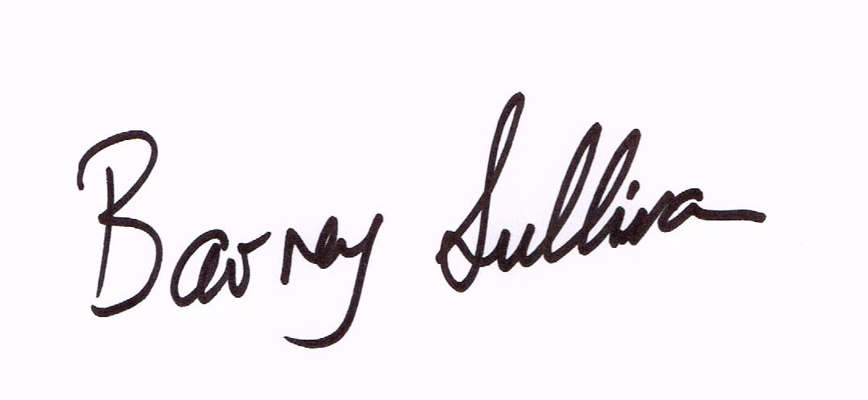
Barney Sullivan, Product Development Manager
26 June 2024
2014


