**SDoC Identification Number1:**

020-SDoC-WS

**Issuer details**

Name2 (of New Zealand manufacturer or importer)**:** Contact Address:

Telephone:

New Zealand Company No. (if applicable):

Email Address:

info@heirloom.co.nz

Heirloom International Limited

3-5 Analie Place,

East Tamaki

Auckland,

New Zealand

+64 9 274 4443

398705

**Medium Risk Article – Details3 (Product name, type, rating, brand, model, batch numbers, and serial numbers, as applicable):**

Heirloom Towel warmers: Studio 1 range: NOTE xx = colour variant

WS1220xx, WS1220Sxx, WS1025xx, WS825xx, WS825Sxx, WS510Exx,

WSE1025, WSE825, WSE825S, WSE510E

**The Medium Risk Article listed above, fully complies:**

**With cited standard(s), as listed**4**:**

Standard number and issue year: Standard number and issue year:

Edition / Amendment status: Edition / Amendment status:

Standard title: Standard title:

AS/NZS ZZ modified Yes No N/A AS/NZS ZZ modified Yes No N/A

**OR Complies with the Conformity Cooperation Agreement**5 Yes No

AS/NZ S60335.1 :2011

AS/NZS60335.2.43:2005

+A1 - A2

+A1-A4

Household and similar electrical appliances

Household and similar electrical appliances

✓   ✓

**Names and addresses of any testing organisation or body**

Name(s): Address(es):

Name(s): Address(es):

21 Tarndale Grove,

Albany,

Auckland, New Zealand

UL International NZ Ltd

**Reference to relevant test reports/certification and the issue date that show how compliance is achieved**

Standard(s) or document(s) used, to show how compliance Report Certification or Document Issue dates(s):

with cited standard is achieved: reference N°(s):

Reference to any management quality system involved:

Additional information6:

15027794-SB00

13429004-SA00 (A1-A5)

13CA47719-SB00

12CA48556-SA00

10CA15417-SA-00

09CA38637-SA00

AS/NZS60335.1 2011 A1-A4, AS/NZS60335.2.43 2018

AS/NZS 60335.1 : 2011 + A1-A3

AS/NZS 60335-2.43 : 2005 + A1-A2

14 December 2023

26 August 2020

9 March 2015

6 December 2012

17 September 2010

2September 2009

**Declaration** **(signed for and on behalf of) Heirloom International Limited**

**Name and position as authorized by the issuer7: Signature:**

**Issuer Identification (as affixed to the article):**

**Date:**

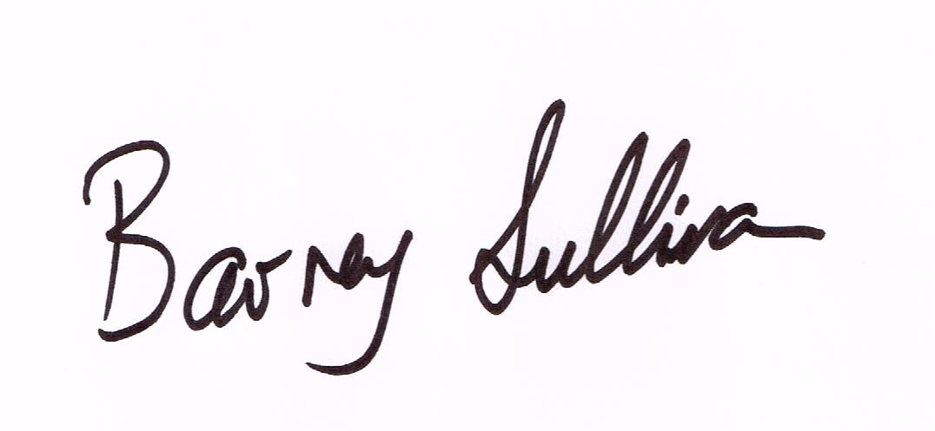

Barney Sullivan, Product Development Manager

15 December 2023

2014

