SDoC Identification Number¹:
020-SDoC-WS

Issuer details

Name² (of New Zealand manufacturer or importer): Contact Address:

Telephone:
New Zealand Company No. (if applicable):
Email Address:

info@heirloom.co.nz
Heirloom International Limited
3-5 Analie Place,
East Tamaki
Auckland,
New Zealand

+64 9 274 4443

398705

Medium Risk Article – Details³ (Product name, type, rating, brand, model, batch numbers, and serial numbers, as applicable):

Heirloom Towel warmers: Studio 1 range: NOTE xx = colour variant
WS1220xx, WS1220Sxx, WS1025xx, WS825xx, WS825Sxx, WS510Exx,
WSE1025, WSE825, WSE825S, WSE510E

The Medium Risk Article listed above, fully complies:

With cited standard(s), as listed⁴:
Standard number and issue year: Standard number and issue year:
Edition / Amendment status: Edition / Amendment status:

Standard title: Standard title:

AS/NZS ZZ modified Yes No N/A AS/NZS ZZ modified Yes No N/A

OR Complies with the Conformity Cooperation Agreement⁵ Yes No

AS/NZ S60335.1 :2011
AS/NZS60335.2.43:2005
+A1 - A2

+A1-A4

Household and similar electrical appliances

Household and similar electrical appliances

Names and addresses of any testing organisation or body

Name(s): Address(es):

Name(s): Address(es):
21 Tarndale Grove,
Albany,
Auckland, New Zealand

UL International NZ Ltd

Reference to relevant test reports/certification and the issue date that show how compliance is achieved

Standard(s) or document(s) used, to show how compliance Report Certification or Document Issue dates(s):
with cited standard is achieved: reference N°(s):

Reference to any management quality system involved:

Additional information⁶:

15027794-SB00
13429004-SA00 (A1-A5)
13CA47719-SB00
12CA48556-SA00
10CA15417-SA-00
09CA38637-SA00

AS/NZS60335.1 2011 A1-A4, AS/NZS60335.2.43 2018
AS/NZS 60335.1 : 2011 + A1-A3
AS/NZS 60335-2.43 : 2005 + A1-A2
14 December 2023
26 August 2020
9 March 2015
6 December 2012
17 September 2010
2September 2009

Declaration (signed for and on behalf of) Heirloom International Limited
Name and position as authorized by the issuer⁷: Signature:

Issuer Identification (as affixed to the article):

Date:

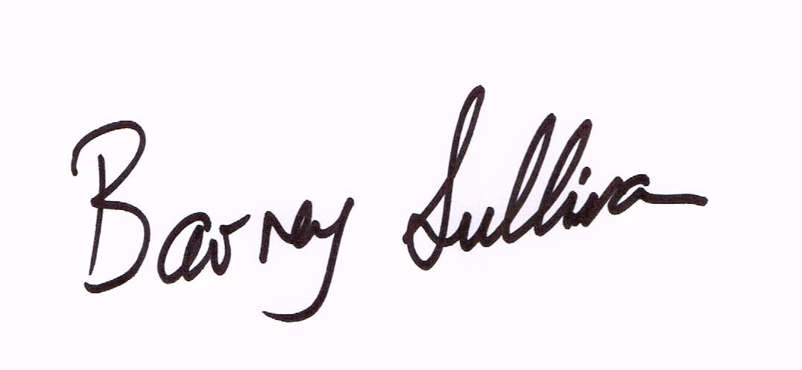
Barney Sullivan, Product Development Manager

15 December 2023
2014


