**SDoC Identification Number1:**

036-SDoC-WSTR

**Issuer details**

Name2 (of New Zealand manufacturer or importer)**:** Contact Address:

Telephone:

New Zealand Company No. (if applicable):

Email Address:

info@heirloom.co.nz

Heirloom International Limited

3-5 Analie Place,

East Tamaki

Auckland,

New Zealand

+64 9 274 4443

398705

**Medium Risk Article – Details3 (Product name, type, rating, brand, model, batch numbers, and serial numbers, as applicable):**

Strata range of single rail towel warmers (xx = colour variant)

WGS460xx; WSS460xx, WGS632xx, WSS632xx , WLS690xx , ; WGSC700, WGSC700N, WGSC700W; WSSC700xx, WHS690, WHS690N, WPS690xx, WGS860xx, WSS860xx , WAS632xx, WAS860, WHSP500 (Note models xxxBC in Report [5]; WTES632xx; WXS632xx Report [6]; WAUS632xx [7]

**The Medium Risk Article listed above, fully complies:**

**With cited standard(s), as listed**4**:**

Standard number and issue year: Standard number and issue year:

Edition / Amendment status: Edition / Amendment status:

Standard title: Standard title:

AS/NZS ZZ modified Yes No N/A AS/NZS ZZ modified Yes No N/A

**OR Complies with the Conformity Cooperation Agreement**5 Yes No

AS/NZ S60335.1 :2020

AS/NZS60335.2.43:2018

Household and similar electrical appliances

Household and similar electrical appliances

✓   ✓

**Names and addresses of any testing organisation or body**

Name(s): Address(es):

Name(s): Address(es):

54 Tarndale Grove,

Albany,

Auckland, New Zealand

UL International NZ Ltd

**Reference to relevant test reports/certification and the issue date that show how compliance is achieved**

Standard(s) or document(s) used, to show how compliance Report Certification or Document Issue dates(s):

with cited standard is achieved: reference N°(s):

Reference to any management quality system involved:

Reference to any management quality system involved:

Additional information6:

6 May 2019

30 July 2021

22 Dec 2022

1 May 2024

26 June 2024

Addition of Annex and Heiko Baton

AS/NZS60335.1 2020

AS/NZS60335.2.43 2018

12759903-SA00

13900496-SA00

14606505-SB00[5]

15254412-SA00 [6]

15321710-SA00 [7]

**Declaration** **(signed for and on behalf of) Heirloom International Limited**

**Name and position as authorized by the issuer7: Signature:**

**Issuer Identification (as affixed to the article):**

**Date:**

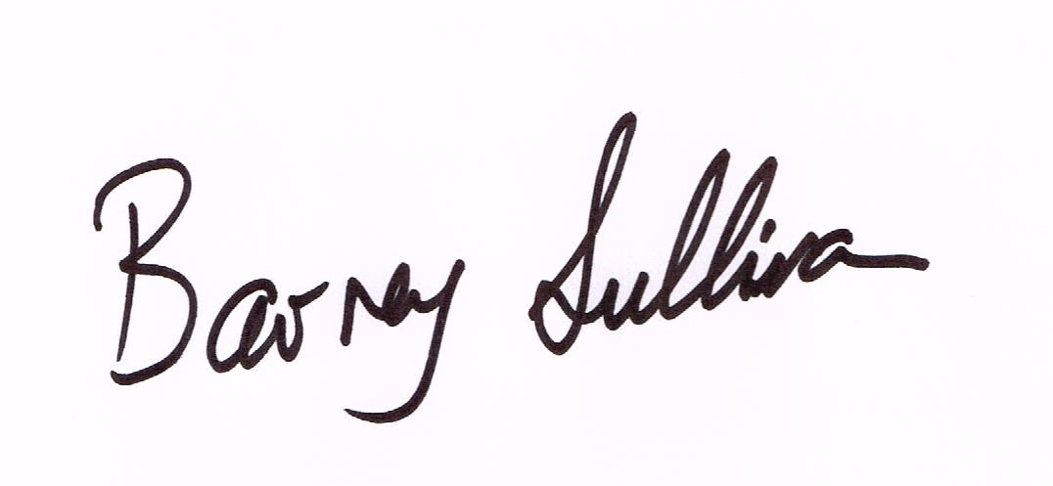

Barney Sullivan, Product Development Manager

26 June 2024

2014

