**SDoC Identification Number1:**

047-SDoC-WSSP

**Issuer details**

Name2 (of New Zealand manufacturer or importer)**:** Contact Address:

Telephone:

New Zealand Company No. (if applicable):

Email Address:

info@heirloom.co.nz

Heirloom International Limited

3-5 Analie Place,

East Tamaki

Auckland,

New Zealand

+64 9 274 4443

398705

**Medium Risk Article – Details3 (Product name, type, rating, brand, model, batch numbers, and serial numbers, as applicable):**

Studio 1 Pole WSSPLV1000 , B, BB, BC, BN, GM, MW, N, . Note BC models added in Report 14606505-SC00

**The Medium Risk Article listed above, fully complies:**

**With cited standard(s), as listed**4**:**

Standard number and issue year: Standard number and issue year:

Edition / Amendment status: Edition / Amendment status:

Standard title: Standard title:

AS/NZS ZZ modified Yes No N/A AS/NZS ZZ modified Yes No N/A

**OR Complies with the Conformity Cooperation Agreement**5 Yes No

AS/NZ S60335.1 2020

AS/NZS60335.2.43:2018

Household and similar electrical appliances

Household and similar electrical appliances

✓   ✓

**Names and addresses of any testing organisation or body**

Name(s): Address(es):

Name(s): Address(es):

54 Tarndale Grove,

Albany,

Auckland, New Zealand

UL International NZ Ltd

**Reference to relevant test reports/certification and the issue date that show how compliance is achieved**

Standard(s) or document(s) used, to show how compliance Report Certification or Document Issue dates(s):

with cited standard is achieved: reference N°(s):

Reference to any management quality system involved:

Reference to any management quality system involved:

Additional information6:

AS/NZS 60335.1 :2020 ;AS/NZS 60335-2.43 : 2018

AS/NZS 60335.1 :2020 +A1 ;AS/NZS 60335-2.43 : 2018

29 July 2021

22 December 2022

13917057-SA00

14606505-SC00

**Declaration** **(signed for and on behalf of) Heirloom International Limited**

**Name and position as authorized by the issuer7: Signature:**

**Issuer Identification (as affixed to the article):**

**Date:**

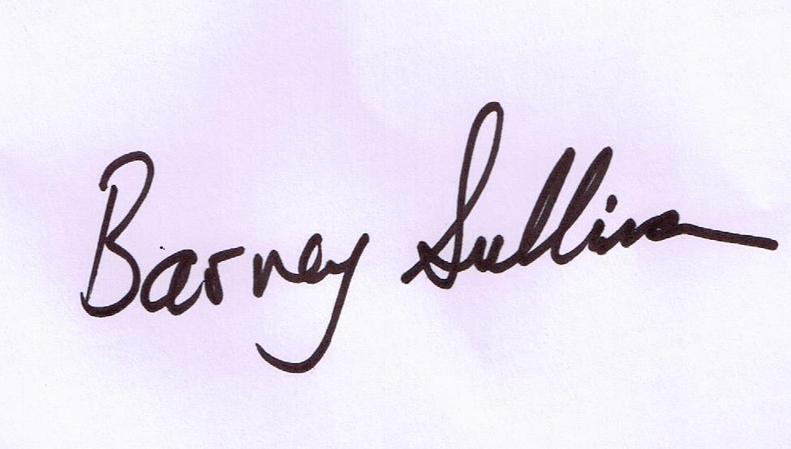

Barney Sullivan, Product Development Manager

9 February 2023

