Outlet Value:
To adjust the flush volume requires altering the float levels on the outlet valve:
The full flush (Fig 1) can be adjusted by sliding the little green box at the bottom of the outlet valve near the cradle. Sliding it DOWN will INCREASE the flush volume and sliding it UP will DECREASE the flush volume.
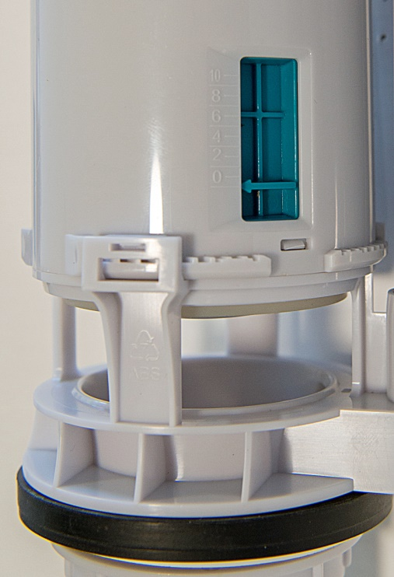
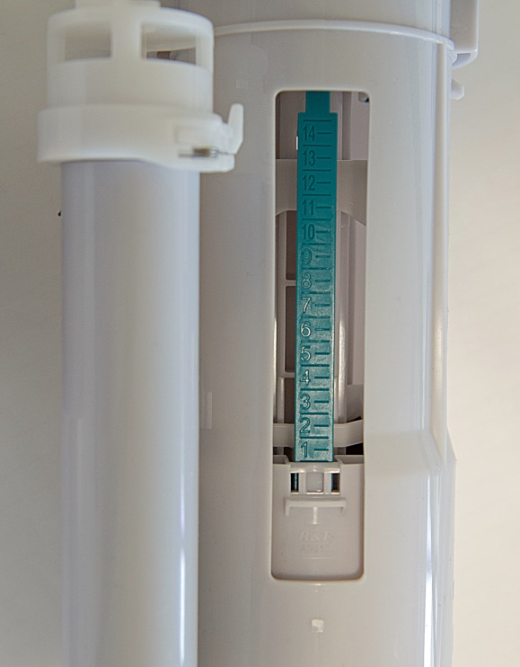
The half flush (Fig 2) can be adjusted by sliding the white tab up along the long green strip. Just as with the half flush, sliding it DOWN will INCREASE the flush volume and sliding it UP will DECREASE the flush volume.
Fig 1 – Full Flush
Fig 2 – Half Flush
Top Inlet Valve:
Use a screw driver to turn the long thin white tube located on the side of the inlet valve. To increase the water volume, turn the screw driver clockwise and anti clockwise to decrease the water volume.

Bottom Inlet Valve:
The water volume of a bottom inlet valve can be adjusted in three ways depending on the amount of adjustment required:
Major Adjustments:
- Slide out the white pin that is located in between the two sections of pipe at the bottom of the inlet - don't lose it, you'll need it later.
- Twist the bottom section clockwise until you hear a click.
- Adjust the inlet capacity by sliding the bottom section either up or down until you achieve the desired inlet capacity. Sliding the bottom section DOWN, elongating the tube, will INCREASE the inlet volume and sliding the bottom section UP, compressing the tube, will DECREASE the inlet volume
- Once you have made the required adjustment, twist the bottom section anticlockwise to lock it into place.
- Slide the little white pin back in between the gap between the two tubes to stop them from shifting.
Medium Adjustments: Surrounding the top tube there is a grey ring - adjusting its position will allow you to make mid-sized alterations of the inlet capacity.
- Located on the outside of the grey ring there is a white pin that you will need to slide in the direction of the 'open' arrow so that you can alter the position of the grey ring on the tube.
- Once it's 'open' you can slide the grey section either up or down the pipe. Sliding it UP will INCREASE the inlet volume. Sliding it DOWN will decrease the inlet volume.
- Once you have made the required adjustment, slide the white pin in the direction of the 'close' arrow, to lock it.
Fine Adjustments: Use a screw driver to turn the long skinny grey tube. Turning it CLOCKWISE will INCREASE the inlet volume and turning it ANTI-CLOCKWISE will DECREASE the inlet volume.
Note: make sure to maximise the water volume held in the cistern.

